CALL FOR SUBMISSIONS:
Community engagement for inclusive rural transformation and gender equality
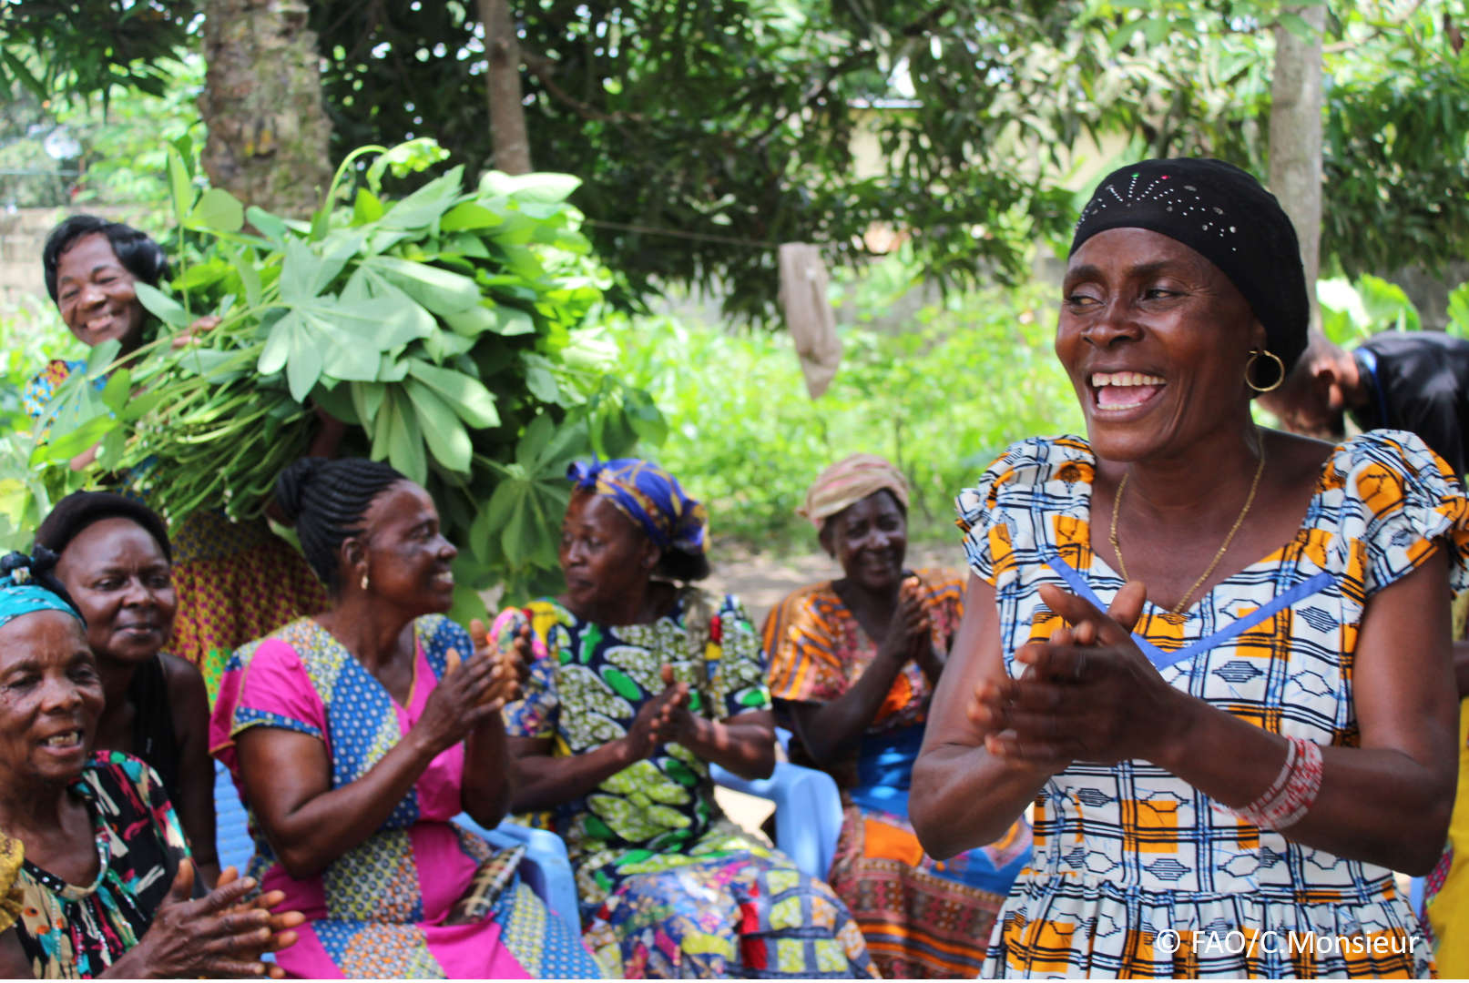
The objective of this call for submissions is to collect good practices, experiences, and lessons learnt on the use of community engagement for inclusive rural transformation and gender equality. The initiative, organized by the Rural Transformation and Gender Equality Division (ESP), seeks to gather insights from a diverse range of contributors, both within FAO and from external stakeholders. Its goal is to share knowledge, foster learning, and guide the scaling up of community engagement and community-led collective action to leave no one behind. The call builds on FAO's past efforts in this area, such as the Community Engagement Days series of webinars.
The call for submissions is open until 27 November 2024.

How to take part in this call for submissions:
To take part in this Call for submissions, please register to the FSN Forum, if you are not yet a member, or “sign in” to your account. Please review the topic note to understand the criteria we are considering for this call. If you wish to learn more about community engagement, you may refer to the background document. Once you have completed this submission template, upload it in the box “Post your contribution” on the call webpage, or, alternatively, send it to fsn-moderator@fao.org.
Please keep the length of submissions limited to 1,500 words and feel also free to attach relevant supporting materials.

Template for submissions

Contact person | Name: Chisango Siazemba Mwindilila  Organization/Unit: Zambia Agricultural Research Institute  Country: Zambia  Email address: chisangomwindilila@yahoo.com
Name/title of the good practice | Food production in agri-food systems (Fostering Community and School Orchards/crops for Food, Income Generation, Human Health, and Climate Resilience)
Where is the good practice taking place? (Multiple selection allowed) | ☐ Europe and Central Asia  ☐ Latin America and the Caribbean  ☐ North Africa and Near East  ☒ Sub-Saharan Africa  ☐ Asia and the Pacific  ☐ North America  ☐ Global
Affiliation | ☐ Farmer and producer organizations  ☐ Trade Union  ☐ Informal community-based, farmer-based or self-help group  ☐ Research and academia  ☒ Government  ☐ Local/traditional authorities  ☐ Private Sector  ☐ Civil Society Organization  ☐ Intergovernmental Organization (e.g. UN system, World Bank)  ☐ Resource Partner/Donor  ☐ Other (please specify)
In which sector(s) and context (s) have you used this community engagement good practice? (Multiple selections allowed) | ☐ Education  ☐ Health and Sanitation  ☒ Food production in agri-food systems (please also tick the sub-categories)  ☒ Crop cultivation  ☐ Fisheries and aquaculture production  ☐ Livestock  ☐ Forestry  ☐ Agroforestry  ☒ Horticulture  ☐ Apiculture (beekeeping)  ☐ Agroecology and sustainable farming practices  ☐ Soil and water management  ☐ Other: ____________  ☐ Post-production in agrifood systems (please also tick the sub-categories)  ☐ Processing and value addition  ☐ Marketing and retailing  ☐ Transporting  ☐ Food loss and waste  ☐ Packaging  ☐ Storage  ☐ Distribution  ☐ Other _________  ☒ Gender Equality  ☒ Climate Action  ☐ Citizenship and Governance  ☐ Social Protection  ☐ Humanitarian and protracted crisis  ☐ Conflict resolution, peace and resilience  ☐ Digital innovation  ☐ Other sector (please specify) _________
Who are the financial partners supporting this good practice, if applicable? | N/A
- In a few sentences, summarize your community engagement good practice.
The Chiefs, headmen, schools and lead farmers will be involved in the planning purposes for the good practice. The selection of lead farmers to be involved will include the farming-oriented youths (both boys and girls), the women, the men and also the physically challenged in all the targeted communities so as to foster a sense of ownership, responsibility leading to adoption and environmental stewardship as well as sustainable agricultural and good practice.
- What problem(s) or challenge(s) does your good practice aim to address through community engagement?
Horticulture (Orchards and key hole gardens), climate change has posed a threat to food security leading to non-communicable diseases among the farming communities in Eastern Province of Zambia. The inclusion of horticultural crops (vegetables in key hole gardens and fruit tree cultivation - Orchards) will be a game changer for the changing climate as it addresses the issues of carbon sequestration in the atmosphere and also contributes significantly to society in terms of provision of healthy foods, vitamins, minerals and recreational as well as scientific research activities. The sale of excess fruits and vegetables will reduce poverty as it acts as a source of income for the farming communities.
- Describe your good practice in more detail. Include the main guiding principles, the desired changes or outcomes you aim to achieve (Theory of Change), and the key phases of implementation.
In the first year, the 200 lead farmers will be selected from each agricultural camp from the three districts (Lundazi, Chadiza and Vubwi) to host the key hole gardens at household level, and 20 schools will be selected to host orchards (fruit tree cultivation) in each district. The number of lead farmers and schools hosting the planned activities will increase every year until year five.
The introduction of horticulture program for this project in farming communities seek to:
Act as a catalytic effort to increased carbon mitigation from the good practice (horticulture), the investments and capacity built can improve diversified agricultural and livelihoods, reduce poverty, and contribute to the sustainability of national economies via improved agricultural productivity. It will also promote reduced GHG emissions from the land sector, from deforestation and forest degradation (REDD+) as an alternative to livelihood rather than charcoal burning, and from sustainable agriculture, as well as to promote smarter land use planning, policies, and practices.

- Who are the key actors and stakeholders involved in the design and implementation of the good practice, and what are their respective roles? Consider local partners, government, local authorities, community radios, civil society, research, the private sector, etc.
Local leadership - they help in the implementation of by-laws at local level and some of which curb climate change, and are included in the system because they have authority over convenient villages for easier implementation of the good practice.
Farmers- this is a target group to carry out the good practices assigned to them.
Traders - this is a group of stakeholders who buy farm produce from the farming community.
Administration Officer, to perform all administrative work that include procurement of materials and other logistics in good time as requested by respective officers
Fields Monitoring Officer, to monitor the progress achieved by the Field Coordinators in the project sites and write reports on the findings. He will also be involved in training of farmers.
Field Officer, to coordinate all field activities that will be carried in the project sites.
Field Technical Officer, to carry out all technical work/ training of farmers
Community radios- to disseminate the progress of activities under implementation.
Government (Ministry of Agriculture), Zambia Agricultural Research institute and Agricultural Extension - to coordinate all the activities that will be carried out under this project and ensure that the project is in line with its objectives through checking the indicators that are set in this project
- How does your intervention ensure inclusivity and equal and meaningful participation within the community?
Describe how your intervention includes and engages different groups within the community. Consider aspects like gender, age, ethnicity, disability status, livelihoods, and other specific conditions (e.g., people living in prolonged crisis, migrants, refugees). Explain how your intervention engages diverse segments of the rural community. Highlight the specific actions or strategies you use to reach these groups. If applicable, mention if your intervention uses specific approaches such as gender-responsive, gender-transformative, intersectionality, or other methods to ensure inclusivity and gender equality.
The inclusion of different groups in this intervention will be based on willingness of the community members to participate so as to easy adoption and selection of the participating community members by random voting done by community members themselves. All the community groups will be called to attend the sensitization, awareness and selection meeting and this will include (aspects like gender, age, ethnicity, disability status, livelihoods, and other specific conditions (e.g., people living in prolonged crisis, migrants, refugees).
In this intervention, it will be important to engage with members of the community and leaders, from the very beginning of the consultation, and to remain communicating even after the project, to help create long lasting relationships and gather feedback which is representative of a large part of the group. This will help pave the way for meaningful interactions, inclusive discussions, and establish better connections with participants.
Strategically, teamwork will be a key feature in this intervention. Working together with others and sharing ideas will definitely drive innovation, improve efficiency and lead to increased productivity. Knowing how to motivate the community members to collaborate is an important skill to help create a cohesive, team-oriented environment. In this intervention, to ensure gender-responsive, gender-transformative, intersectionality collaborative approach such as with the stakeholders, setting of clearly defined goals for each team, defining of team member roles, promotion of creativity, organization of the process, fostering diversity and inclusion, sharing of information and resources as well as requesting for feedback will be ideal strategies for this intervention.

- By using community engagement, what results and impacts have your good practice achieved?
Please provide specific examples and evidence demonstrating the effectiveness of your intervention, focusing on both qualitative and quantitative outcomes related to livelihoods and well-being improvements.
Community engagement in the above-mentioned intervention, resulted into many social benefits, including opportunities for community engagement, fostering interactions between diverse communities, as well as health and environmental stewardship education (Dyg et al., 2020; Lawson, 2005).
A key economic benefit as an example, is the reduction in grocery expenses when receiving harvest from community orchards and key hole gardens; a conservative estimate is that a family can save approximately ZMK 5000 a year (Patel 1991). Community agriculture can also increase property values, local employment opportunities, and income (Hodgson et al., 2011).
Community agriculture help foster environmental connectedness, political consciousness, and activism among youth and adults (Spilkova, 2017). Additionally, it decreases stormwater runoff and air pollution, and increase biodiversity and species habitat.

- Among these results, has the good practice led to improvements in terms of gender equality, women’s empowerment, and/or social inclusion?
Describe the behavioral changes in terms of gender that the good practice promotes, emphasizing agency, leadership, and participation in local governance. Include efforts to challenge discriminatory norms and unequal power dynamics. Highlight also how the intervention has supported the well-being (including psychological resilience) of marginalized groups and enhanced their inclusion and participation in decision-making processes.
Indeed yes, the participation of women and men involved in this good practice played roles significantly and there was increased women’s empowerment and opportunities for community engagement, interactions between diverse communities for all the community members involved. Most women participated as leaders such secretaries, chairladies etc. Gender dynamics, as a fundamental aspect of social structures, play a profound role in shaping individuals' lives and societal norms of which all community participants had equal rights. Mindfulness-based interventions are among the most common therapeutic approaches for enhancing psychological resilience and in this case inclusive involvement of all farming community members were considered from the inception of the program.

- What key challenges did you encounter while implementing the community engagement activities, and how did you address them?
Include any resistance from communities, pushback, or issues related to unequal power dynamics, if applicable.
Lack of trust, many people simply do not trust that their voices will actually be heard. Some community members believed that the local community had influence for all negatives.
Solution applied, the trust was built by proving that people’s options are worth something and manage their expectations and also showed that their words have the power to change their surroundings.
A lack of time, another hard truth for many is that many people simply do not have the time to get involved with community engagement.
Solution applied, participants were asked to share their views from the comfort of their own to suggest number of times for activities in a given quarter and also their preferred time of the day for them to carry activities of which was resolved to meet twice a month and all in the morning.
Resistance to change, another challenge to community engagement was that people resisted to change.
Solution applied, Shared the 'why' behind the change, its benefits, and addressing concerns openly helped dissipate doubts and engaged the community involvement.

- What are the key lesson learned from your community engagement good practice?
The feedback from the community and recording of progress activities and results was done and hence what was done well and what didn’t go well were the key lessons learnt during the community engagement of the good practice.
- Has this practice been replicated in the same context or in different contexts?
What are the required conditions to replicate and adapt the practice in another context/geographical area?
This practice was replicated in the different context and the required conditions to replicate included the following; Start off with a transparent community selection process and share results, map community priorities and identify community leaders through community assessments, hold preliminary meetings with community leaders and enlist their support to mobilize community participation, hold community assembly meetings to elect local representation to coordinate program activities and allow communities to prioritize and select quick impact projects to solidify support and galvanize local participation.
- How sustainable are the results achieved by this good practice?
Describe the key elements that need to be in place to make the initiative sustainable, including enabling environment (legal and policy frameworks and institutions), local ownership, accountability, etc.
The results achieved are sustainable and answer the call for Goal No 1,2,3,4, and 5 of the SDGs for good practices.
The key elements include;
Enabling Environment (Legal and Policy Frameworks and institutions), strong legal and policy frameworks are essential. These should support sustainable practices through regulations, incentives, and enforcement mechanisms. Effective institutions at local, national, and international levels are crucial. They should be capable of implementing policies, monitoring progress, and ensuring compliance.
Local Ownership (Community Involvement and Capacity Building), Engaging local communities in the planning and implementation phases ensures that the practices are culturally appropriate and meet the actual needs of the people and providing training and resources to local stakeholders helps build the necessary skills and knowledge to maintain and adapt the practices over time.
Economic Viability (Funding and Resources and market access), sustainable initiatives need reliable funding sources. This can include government funding, private investments, or community-based financing and ensuring that products or services resulting from the initiative have access to markets can help sustain economic viability.
Environmental Considerations (Resource Management and Environmental Impact Assessments), sustainable practices should include efficient use of natural resources to avoid depletion and ensure long-term availability and also regular assessments can help identify and mitigate any negative environmental impacts.
Monitoring and Evaluation (Continuous Improvement Transparency and Accountability), regular monitoring and evaluation allow for adjustments and improvements to the practices, ensuring they remain effective and relevant and also clear reporting mechanisms help maintain trust and accountability among stakeholders.
By integrating these elements, good practices can achieve long-term sustainability, benefiting both the environment and the communities involved.

- Based on the conversations FAO held during the Community Engagement days, a definition of community engagement for empowerment was proposed:

“Ccommunity engagement for empowerment and community-led collective action can be defined as an inclusive and participatory process that enables community members to become active agents of change in decisions affecting their lives, health, and environment. This process develops their capacity to achieve sustainable outcomes for improved rural livelihoods. Embracing a rights-based approach, it prioritizes the agency and participation of all community members, regardless of gender identity, sexual orientation, age, ethnicity, caste, socioeconomic status, political affiliation, migration status, or ability/disability. Indeed, inclusive approaches recognize the complexities of overlapping marginalization and discrimination that can exclude different community members from decision-making processes and implement strategies to foster their participation, agency and empowerment.”

We invite you to contribute to this definition. What would you add or change? Please share your thoughts, suggestions, and any additional elements you believe are crucial for a comprehensive understanding of community engagement approaches aimed at community-led collective action for inclusive rural transformation, people’s empowerment and gender equality.
Our thought, the definition is good enough for implementation of a good practice in a farming community, however, l would add the elements of planning, organizing, leading and controlling which is the principle of leadership by local leadership as well as stakeholders.

- Based on your experience, what gaps or areas for improvement still need to be addressed in the field of community engagement?
Communication is something I think we would improve. While experts are comfortable speaking with others and sharing their ideas, they sometimes struggle to clearly articulate their thoughts or listen actively to others. To address this, experts need to practice active listening techniques and seeking feedback from communities to ensure that they are communicating effectively.

- What do you think is FAO's role in the field of community engagement? How can FAO support and enhance interventions like yours, if applicable? Consider aspects such as policy advocacy, capacity development, funding, technical assistance, knowledge production and sharing, and fostering partnerships.
FAO's role in the field of community engagement includes the following;
Policy Advocacy, FAO advocates for policies that support sustainable agricultural practices and rural development. This includes promoting gender equality and the inclusion of marginalized groups in decision-making processes.
Capacity Development, FAO provides training and resources to build the capacity of local communities.
Funding, FAO can offer financial support for community projects through various funding mechanisms and partnerships. This helps communities implement sustainable agricultural practices and improve food security
Technical Assistance, FAO provides technical expertise and support to help communities adopt best practices in agriculture, disaster risk management, and climate resilience
Knowledge Sharing, FAO facilitates the exchange of knowledge and best practices through research, publications, and community networks. This helps communities stay informed about innovative solutions and successful interventions.

FAO Can Support our Interventions in the following ways;
Through policy Advocacy, can help advocate for policies that support our community’s needs, ensuring that local voices are heard at national and international levels.
Capacity Development, can provide training programs and resources to enhance the skills and knowledge of your community members, enabling them to implement effective interventions.
Through funding, can assist in securing funding for our projects, either through direct grants or by connecting you with potential donors and partners.
Technical Assistance, can offer technical support to help you design and implement interventions that are sustainable and effective.
Knowledge Sharing: FAO can facilitate access to research, case studies, and best practices that can inform and improve your interventions.

Link(s) to specific references about your good practice (e.g., reports, communication products, videos, articles) | Please include attachment(s) or add here link(s) to documents/videos/podcasts/other with specific references.  https://treecouncil.org.uk/wp-content/uploads/2019/12/School-Orchards.pdf  https://www.researchgate.net/publication/377814489_  Restoring_degraded_grassland_  Orchards_enrich_school_yards_for_prosperity

The call for submissions is directly aligned with the thematic components of collective action within FAO's Programme Priority Areas (PPAs), specifically Better Life 1 (Gender Equality and Rural Women’s Empowerment), Better Life 2 (Inclusive Rural Transformation) and Better Life 3 (Agriculture and Food Emergencies).

